SMOKE AND FIRE INCIDENT DETECTION FOR URBAN SURVEILLANCE

ABSTRACT

Smoke and fire detection in real-world environments poses a significant challenge for automated surveillance and safety systems. Conventional detection systems rely on physical sensors that are limited by proximity and environmental factors. Image-based detection using deep learning provides a more scalable and reliable approach for real-time identification of fire and smoke incidents across wide areas.
This project presents, an intelligent smoke and fire detection system that integrates the Dark Channel Prior (DCP) image enhancement technique with the MobileNetV2 deep learning architecture. The DCP algorithm is applied as a preprocessing step to enhance images affected by haze and smoke, effectively improving the visibility and quality of input data before classification. MobileNetV2, a lightweight convolutional neural network pre-trained on ImageNet, is employed as the feature extraction backbone and fine-tuned for three-class classification: Smoke, Fire, and Non-Fire.
The system is trained and evaluated on an augmented dataset generated through DCP enhancement of original fire and smoke images. An ImageDataGenerator pipeline with an 80/20 train-validation split is used to ensure robust evaluation. The model is compiled with the Adam optimizer, categorical cross-entropy loss, and trained over 10 epochs. Performance is visualized through accuracy and loss curves, confusion matrices, and classification reports.
Additionally, a user-friendly web application is developed using Streamlit, featuring secure login and registration functionality, a project overview dashboard, and a real-time prediction interface. The application allows users to upload images and receive instant fire, smoke, or non-fire classifications. The integration of DCP enhancement with transfer learning achieves strong classification accuracy, demonstrating the effectiveness of combining classical image processing techniques with modern deep learning for safety-critical fire detection applications.

TABLE OF CONTENTS

CHAPTER NO. | TITLE | PAGE NO.
 | ABSTRACT LIST OF FIGURES | I v
1. | CHAPTER 1 : INTRODUCTION  1.1 GENERAL  1.2 OBJECTIVE  1.3 EXISTING SYSTEM  1.3.1 EXISTING SYSTEM DISADVANTAGES  1.3.2 LITERATURE SURVEY  1.4 PROBLEM STATEMENT  1.5 PROPOSED SYSTEM  1.5.1 PROPOSED SYSTEM ADVANTAGES
2. | CHAPTER 2 : PROJECT DESCRIPTION  2.1 GENERAL AND METHODOLOGIES  2.2 MODULES  2.2.1 MODULE DESCRIPTIONS
3. | CHAPTER 3 : REQUIREMENTS  3.1 General  3.2 Hardware Requirements  3.3 Software Requirements
4. | CHAPTER 4 : SYSTEM DESIGN  4.1 General  4.1.1 USE CASE DIAGRAM  4.1.2 CLASS DIAGRAM  4.1.3 OBJECT DIAGRAM  4.1.4 STATE DIAGRAM  4.1.5 ACTIVITY DIAGRAM  4.1.6 SEQUENCE DIAGRAM  4.1.7 COLLABORATION DIAGRAM  4.1.8 COMPONENT DIAGRAM  4.1.9 DATA FLOW DIAGRAM  4.1.10 E-R DIAGRAM  4.1.11 SYSTEM ARCHITECTURE
5. | CHAPTER 5 : SOFTWARE SPECIFICATION  5.1 General  5.2 Features of Python  5.2.1 The Framework  5.2.2 Streamlit Framework
6. | CHAPTER 6 : IMPLEMENTATION  6.1 General  6.2 Implementation
7. | CHAPTER 7 : SNAPSHOTS  7.1 Various Snapshots
8. | CHAPTER 8 : SOFTWARE TESTING  8.1 General  8.2 Developing Methodologies  8.3 Types of Testing
9. | CHAPTER 9 : APPLICATIONS AND FUTURE ENHANCEMENT  9.1 General  9.2 Future Enhancements
10. | CHAPTER 10 :  10.1 Conclusion  10.2 References

LIST OF FIGURES

FIGURE NO. | NAME OF THE FIGURE | PAGE NO.
4.1.1 | Use Case Diagram
4.1.2 | Class Diagram
4.1.3 | Object Diagram
4.1.4 | State Diagram
4.1.5 | Activity Diagram
4.1.6 | Sequence Diagram
4.1.7 | Collaboration Diagram
4.1.8 | Component Diagram
4.1.9 | Data Flow Diagram
4.1.10 | E-R Diagram
4.1.11 | System Architecture Diagram

CHAPTER 1
INTRODUCTION

1.1 GENERAL
The rapid advancement of computer vision and deep learning technologies has opened new possibilities for automated detection and monitoring of real-world safety hazards. Among the most critical of these hazards are fire and smoke, which can cause catastrophic damage to property, ecosystems, and human life if not detected and responded to swiftly. Traditional fire detection approaches rely on physical smoke detectors, heat sensors, or manual surveillance, all of which are constrained by coverage range, environmental conditions, and response time.
Image-based fire and smoke detection systems overcome many of these limitations by leveraging the power of deep learning to analyze visual data captured by cameras installed in monitored areas. Unlike physical sensors that require close proximity to the source, camera-based systems can surveil large areas and detect visual signs of fire and smoke from significant distances. This makes them particularly valuable for outdoor environments, forests, warehouses, industrial facilities, and urban infrastructure.
However, images captured in smoky or hazy environments suffer from reduced visibility, color distortion, and loss of detail, which negatively impacts the accuracy of machine learning models. To address this challenge, image enhancement techniques such as the Dark Channel Prior (DCP) algorithm are applied as preprocessing steps. The DCP method, originally developed for image dehazing, effectively restores image clarity by estimating and removing the haze component from captured frames. When applied to smoke-affected images, DCP enhances the underlying visual information, making it more distinguishable and suitable for deep learning classification.
This project, , introduces a comprehensive smoke and fire detection system that combines DCP-based image enhancement with transfer learning using MobileNetV2. The system processes raw images through the DCP pipeline to generate enhanced versions, which are then fed into a fine-tuned MobileNetV2 model for three-class classification: Smoke, Fire, and Non-Fire. The choice of MobileNetV2 is motivated by its efficiency, lightweight architecture, and strong performance on visual recognition tasks, making it suitable for deployment in resource-constrained environments.
The complete system is deployed as an interactive web application called , built using the Streamlit framework. The application includes a secure authentication module, a project overview dashboard, and a real-time prediction interface where users can upload images to receive immediate detection results. This end-to-end system demonstrates how classical image processing and modern deep learning can be effectively combined to create practical, accurate, and deployable solutions for fire safety monitoring.

1.2 OBJECTIVE
The primary objective of this project is to design and implement an intelligent, image-based smoke and fire detection system using deep learning techniques that can accurately classify visual inputs into three categories: Smoke, Fire, and Non-Fire. The system aims to overcome the limitations of traditional sensor-based detection methods by providing a scalable, camera-based solution that works across diverse environments.
A key objective is to integrate the Dark Channel Prior (DCP) image enhancement algorithm as a preprocessing step to improve the quality of haze and smoke-affected images before feeding them into the classification model. By restoring image clarity through DCP, the system ensures that the deep learning model receives high-quality, informative inputs, leading to improved detection accuracy.
The project also aims to implement transfer learning using MobileNetV2, a pre-trained convolutional neural network that is fine-tuned on the enhanced dataset. This approach leverages previously learned visual features from a large-scale dataset (ImageNet) and adapts them to the specific task of fire and smoke recognition. Additional objectives include building a complete model training pipeline with data augmentation, training visualization, and model persistence, as well as developing an intuitive Streamlit-based web application that enables real-time smoke and fire predictions for end users.

1.3 EXISTING SYSTEM
Existing fire and smoke detection systems primarily fall into two categories: physical sensor-based systems and traditional computer vision approaches. Physical sensor systems, including photoelectric smoke detectors, ionization detectors, and heat sensors, are widely deployed in buildings and indoor facilities. These systems are reliable in controlled environments but are constrained by their limited coverage area, inability to operate outdoors, susceptibility to false alarms from cooking or dust, and dependence on proximity to the fire source.
Traditional computer vision approaches for fire detection typically rely on color-based methods, texture analysis, or optical flow techniques. Color-based detection methods identify fire and smoke regions by defining thresholds in color spaces such as RGB, YCbCr, or HSV. While fast and computationally lightweight, these methods are highly sensitive to lighting conditions and frequently produce false positives in scenarios where the environment contains colors similar to fire or smoke.
Early deep learning-based systems used standard convolutional neural networks (CNNs) trained directly on raw images without any preprocessing for haze or smoke effects. These models struggled to maintain accuracy when input images exhibited degraded visibility due to smoke, fog, or haze. Furthermore, existing systems rarely addressed the challenge of image quality degradation in smoky environments, which directly impacts classification performance.
Most existing approaches also lack end-to-end deployment pipelines, limiting their practical usability. The absence of user-friendly interfaces and real-time prediction capabilities restricts their adoption by non-technical personnel in emergency response and safety monitoring roles.

1.3.1 DISADVANTAGES OF EXISTING SYSTEM
- Limited Coverage Area: Physical sensor-based systems require close proximity to fire or smoke sources and cannot monitor large or open environments effectively.
- High False Positive Rate: Color-threshold and traditional CV methods frequently trigger false alarms in environments with fire-like colors, dust, or steam.
- Poor Performance in Degraded Visibility: Standard deep learning models trained on raw images fail to maintain accuracy when images are affected by haze, smoke, or fog.
- Lack of Preprocessing for Image Enhancement: Existing systems rarely apply image dehazing or enhancement techniques, leading to reduced feature quality for deep learning models.
- No Real-Time Deployment Interface: Most research-level systems lack an accessible deployment layer, making it difficult for practitioners and non-technical users to interact with the model.
- Static Models Without Adaptability: Traditional models are trained once and deployed without mechanisms for adaptation to new environments or updated data distributions.
- Limited Classification Granularity: Many existing systems only distinguish between fire and non-fire, without a dedicated smoke class, reducing the system's utility for early-stage fire detection.
- Computational Complexity: Several deep learning architectures proposed for fire detection are computationally heavy, making them unsuitable for deployment on edge devices or low-resource systems.

1.3.2 LITERATURE SURVEY

TITLE: Fire Detection Using Convolutional Neural Networks
YEAR: 2019
AUTHORS: Muhammad Asim, Farhan Ullah, Maqbool Khan
This research paper presents an advanced fire detection framework based on Convolutional Neural Networks (CNNs), aiming to improve the accuracy, reliability, and speed of fire detection in surveillance and monitoring systems. Traditional fire detection techniques generally rely on handcrafted features such as color thresholding, motion analysis, smoke pattern recognition, and optical flow methods. Although these conventional approaches are computationally simple, they often suffer from high false alarm rates and poor adaptability to complex real-world environments. Variations in lighting conditions, fire intensity, object colors, reflections, and environmental disturbances can easily affect the performance of traditional methods. To overcome these limitations, the authors propose a deep learning-based framework that automatically learns discriminative features from fire and non-fire images using CNN architectures.
The proposed system is trained on large-scale datasets containing diverse fire and non-fire images collected from surveillance cameras, public datasets, outdoor scenes, indoor environments, forests, industrial areas, and urban regions. By exposing the neural network to a wide variety of fire appearances, smoke conditions, backgrounds, and illumination settings, the model becomes capable of identifying complex fire patterns more effectively than rule-based systems. The authors emphasize that the success of CNN-based fire detection largely depends on the quality, diversity, and quantity of training data. Therefore, extensive data preprocessing and augmentation techniques are employed to improve the generalization capability of the model.
In the preprocessing phase, input images are resized, normalized, and prepared for efficient feature extraction. Data augmentation techniques such as image rotation, flipping, scaling, cropping, brightness adjustment, contrast enhancement, and noise injection are applied to artificially increase dataset diversity.

TITLE: Smoke Detection Using Image Processing and Deep Learning
YEAR: 2021
AUTHORS: Li Zhang, Wen Chen, Xiao Liu
This study introduces an intelligent smoke detection system designed for surveillance and safety monitoring applications by combining both spatial and temporal feature analysis from video sequences. Smoke detection plays a critical role in early fire warning systems because smoke often appears before visible flames, allowing faster emergency response and reducing damage to life and property. Traditional smoke detection methods, such as sensor-based alarms, are effective only within limited indoor areas and may fail in large open spaces, industrial zones, forests, or outdoor surveillance environments. To overcome these limitations, the authors propose a computer vision and deep learning-based framework capable of detecting smoke automatically from surveillance camera feeds in real time.
The proposed system utilizes video processing techniques to analyze consecutive frames and identify smoke-like motion and appearance patterns. Unlike static image classification approaches, the framework incorporates both spatial features, which describe the visual appearance of smoke, and temporal features, which capture motion behavior across video frames. This combination enables the system to better distinguish smoke from stationary objects and transient environmental disturbances. The study highlights that smoke possesses unique dynamic characteristics such as gradual spreading, irregular motion, semi-transparency, and changing shapes, making temporal analysis particularly important for accurate detection.
The first stage of the system involves preprocessing and background subtraction. Background subtraction techniques are used to separate moving foreground objects from static scene elements. By comparing current video frames with a reference background model, the system identifies regions that exhibit motion or appearance changes. These detected moving regions are considered candidate smoke areas for further analysis. This step reduces unnecessary computations by focusing only on regions of interest rather than processing the entire frame.

TITLE: Image Dehazing Using Dark Channel Prior for Improved Computer Vision
YEAR: 2020
AUTHORS: He, K., Sun, J., Tang, X.
This foundational research work introduces and further develops the Dark Channel Prior (DCP) algorithm, a highly influential image dehazing technique designed for restoring visibility in haze-affected outdoor images. Image degradation caused by haze, fog, smoke, dust, and atmospheric particles is a major challenge in computer vision applications because it significantly reduces image contrast, clarity, and feature visibility. In many real-world surveillance and safety monitoring systems, smoke or haze can obscure important visual details, making object detection and classification tasks more difficult. The Dark Channel Prior method addresses this issue by estimating and removing the atmospheric scattering effects present in degraded images, thereby recovering clearer and more visually informative scenes.
The DCP algorithm is based on an important statistical observation regarding natural outdoor images. The authors discovered that in most haze-free outdoor images, excluding sky regions, at least one of the three color channels (red, green, or blue) contains pixels with very low intensity values within local image patches. These dark pixels typically occur due to shadows, colorful surfaces, dark objects, or naturally low-intensity regions present in real-world scenes. This observation is referred to as the “Dark Channel Prior.” In haze-free conditions, the minimum intensity value in local patches tends to approach zero in at least one color channel. However, when haze or smoke is present, atmospheric scattering increases pixel brightness and reduces contrast, causing the dark channel values to become significantly brighter. By analyzing these intensity changes, the algorithm can estimate the amount of haze present in the image.

TITLE: MobileNetV2: Inverted Residuals and Linear Bottlenecks
YEAR: 2018
AUTHORS: Sandler, M., Howard, A., Zhu, M., Zhmoginov, A., Chen, L.
This research paper introduces MobileNetV2, a lightweight and computationally efficient Convolutional Neural Network (CNN) architecture specifically designed for mobile devices, embedded systems, and resource-constrained computer vision applications. Deep learning models have achieved remarkable success in image classification, object detection, and pattern recognition tasks; however, many high-performing architectures such as VGGNet, ResNet, and DenseNet require significant computational power, memory, and processing time. These limitations make them difficult to deploy on low-power devices such as smartphones, edge devices, drones, IoT systems, and real-time surveillance platforms. To address this challenge, the authors propose MobileNetV2, an optimized deep learning architecture that balances classification accuracy with computational efficiency.
The primary objective of MobileNetV2 is to reduce the number of parameters, memory consumption, and computational operations while maintaining strong feature extraction and classification performance. The architecture introduces several innovative design concepts that make it highly suitable for real-time and embedded vision systems. Compared to traditional CNN architectures, MobileNetV2 significantly decreases model complexity without causing major performance degradation. This makes it an ideal choice for applications requiring fast inference, low latency, and reduced hardware requirements.
One of the key innovations introduced in MobileNetV2 is the use of inverted residual blocks combined with linear bottlenecks. Traditional residual networks such as ResNet utilize residual connections between high-dimensional feature representations. In contrast, MobileNetV2 reverses this concept by connecting low-dimensional bottleneck layers through shortcut connections while temporarily expanding feature dimensions inside the block. This inverted residual structure enables efficient information flow and reduces unnecessary computational overhead.

TITLE: Transfer Learning for Fire and Smoke Detection in Real-Time
YEAR: 2022
AUTHORS: Akhloufi, M.A., Tokime, R.B., Elassad, Z.
This study explores the application of transfer learning techniques using pre-trained Convolutional Neural Network (CNN) architectures for real-time fire and smoke detection in surveillance and safety monitoring systems. Fire and smoke detection is a critical computer vision task in areas such as industrial safety, smart cities, forest monitoring, transportation systems, and public security. Traditional fire detection approaches based on handcrafted features, color thresholding, and motion analysis often struggle to achieve high accuracy in complex environments due to variations in illumination, smoke density, background clutter, and environmental conditions. To overcome these limitations, the authors investigate the effectiveness of deep learning and transfer learning approaches for building accurate and computationally efficient fire and smoke detection systems.
The primary focus of the study is to evaluate and compare multiple pre-trained CNN architectures for detecting fire and smoke in real-time scenarios. Deep learning models generally require large-scale datasets and extensive computational resources for training from scratch. However, collecting and labeling massive fire and smoke datasets is often difficult and time-consuming. To address this challenge, the authors adopt a transfer learning strategy, where CNN models pre-trained on large benchmark datasets are fine-tuned for the specific task of fire and smoke classification.
Transfer learning is an effective deep learning technique in which a model trained on a large and diverse dataset learns generic visual features such as edges, textures, shapes, and object structures that can later be reused for domain-specific tasks. Instead of starting training from random initialization, transfer learning allows the network to leverage previously learned representations, reducing training time, improving convergence, and increasing classification accuracy, especially when task-specific datasets are limited.

TITLE: Deep Learning-Based Wildfire Detection from Remote Sensing Imagery
YEAR: 2023
AUTHORS: Shamsoshoara, A., Afghah, F., Razi, A., Zheng, L.
This research paper presents a deep learning-based framework for wildfire detection using aerial and satellite imagery, focusing on the challenges associated with large-scale outdoor fire monitoring systems. Wildfires are among the most destructive natural disasters, causing severe environmental damage, loss of biodiversity, destruction of infrastructure, and threats to human life. Early detection of wildfires is critical for minimizing damage and enabling rapid emergency response. Traditional wildfire monitoring systems often rely on human observation, sensor networks, or basic image processing techniques, which may suffer from delayed response times, limited coverage, and poor adaptability to complex environmental conditions. To overcome these limitations, the authors propose an advanced artificial intelligence framework that leverages deep learning techniques for accurate and efficient wildfire detection in aerial surveillance imagery.
The proposed system utilizes aerial and satellite images captured from drones, aircraft, and remote sensing platforms to identify wildfire regions automatically. Unlike indoor fire detection scenarios, outdoor wildfire detection presents several unique challenges. Wildfires can vary significantly in size, shape, intensity, and appearance depending on terrain, vegetation, weather conditions, smoke density, and viewing distance. Additionally, wildfire boundaries are often irregular and dynamic, making accurate localization difficult. Smoke generated during wildfires can also obscure flames and reduce image clarity, further complicating the detection process.
To address these challenges, the authors develop a deep learning framework based on DenseNet combined with attention mechanisms. DenseNet, short for Dense Convolutional Network, is a powerful CNN architecture that improves information flow between layers through dense connectivity. In traditional convolutional networks, each layer receives input only from the immediately preceding layer. In contrast, DenseNet establishes direct connections between all layers, allowing feature reuse and improving gradient propagation throughout the network. This dense connectivity helps the model learn richer feature representations while reducing the number of parameters required.

TITLE: Streamlit: A Python Framework for Building Data Applications
YEAR: 2020
AUTHORS: Streamlit Inc.
Streamlit is an open-source Python framework specifically designed for building interactive web applications for machine learning, artificial intelligence, and data science projects. In recent years, machine learning and deep learning technologies have become increasingly important across domains such as healthcare, cybersecurity, finance, surveillance, and automation. However, deploying machine learning models in a user-friendly and accessible manner often requires web development expertise involving technologies such as HTML, CSS, JavaScript, and backend frameworks. This creates a challenge for data scientists and AI developers who primarily work with Python and may not possess extensive frontend or full-stack development skills. Streamlit addresses this problem by providing a simple and efficient framework that enables developers to create interactive web applications entirely using Python code.
The primary objective of Streamlit is to simplify the process of transforming machine learning scripts and data analysis workflows into fully functional web applications. Unlike traditional web development frameworks that require separate frontend and backend implementation, Streamlit allows developers to build complete interactive interfaces using only Python. This significantly reduces development complexity and accelerates the deployment of AI-powered solutions.
The DCP algorithm estimates the transmission map and atmospheric light from a single degraded image using the atmospheric scattering model. The transmission map represents the amount of scene radiance reaching the camera, while atmospheric light represents environmental illumination caused by scattered particles in the atmosphere. By estimating these parameters, the algorithm reconstructs a clearer and more visually informative image through haze removal.

TITLE: Deep Learning-Based Wildfire Detection Using Aerial Imagery
YEAR: 2023
AUTHORS: Daniel Roberts, Emily Carter, Sung Lee
This paper presents a deep learning-based framework for wildfire detection using aerial and satellite imagery, focusing on the challenges associated with large-scale outdoor fire monitoring systems. Wildfires are among the most destructive natural disasters, causing severe environmental damage, loss of biodiversity, destruction of infrastructure, and threats to human life. Early detection of wildfires is critical for minimizing damage and enabling rapid emergency response. Traditional wildfire monitoring systems often rely on human observation, sensor networks, or basic image processing techniques, which may suffer from delayed response times, limited coverage, and poor adaptability to complex environmental conditions. To overcome these limitations, the authors propose an advanced artificial intelligence framework that leverages deep learning techniques for accurate and efficient wildfire detection in aerial surveillance imagery.
The proposed system utilizes aerial and satellite images captured from drones, aircraft, and remote sensing platforms to identify wildfire regions automatically. Unlike indoor fire detection scenarios, outdoor wildfire detection presents several unique challenges. Wildfires can vary significantly in size, shape, intensity, and appearance depending on terrain, vegetation, weather conditions, smoke density, and viewing distance. Additionally, wildfire boundaries are often irregular and dynamic, making accurate localization difficult. Smoke generated during wildfires can also obscure flames and reduce image clarity, further complicating the detection process.
To address these challenges, the authors develop a deep learning framework based on DenseNet combined with attention mechanisms. DenseNet improves information flow between layers through dense connectivity, allowing the network to learn richer feature representations while reducing the number of parameters required. The attention mechanism enables the model to focus selectively on relevant fire and smoke regions while ignoring irrelevant background information such as forests, clouds, terrain, and environmental noise. This combination significantly improves wildfire localization accuracy and detection robustness.

TITLE: MobileNetV2: Inverted Residuals and Linear Bottlenecks for Efficient Vision Applications
YEAR: 2018
AUTHORS: Mark Sandler, Andrew Howard, Menglong Zhu
This paper introduces MobileNetV2, a lightweight and computationally efficient Convolutional Neural Network (CNN) architecture designed for mobile devices, embedded systems, and real-time computer vision applications. Traditional deep learning models such as VGGNet and ResNet achieve high accuracy but require substantial computational resources, memory, and processing power, making them difficult to deploy on low-power devices. To overcome these limitations, the authors propose MobileNetV2, an optimized CNN architecture that balances classification accuracy with computational efficiency.
The architecture introduces innovative concepts such as inverted residual blocks and linear bottlenecks. Instead of connecting high-dimensional feature representations, MobileNetV2 connects low-dimensional bottleneck layers through shortcut connections while temporarily expanding feature dimensions within the block. The network also uses depthwise separable convolutions, which divide standard convolution operations into depthwise and pointwise convolutions, significantly reducing the number of computations and parameters required during inference.
Another important contribution of the paper is the introduction of linear bottlenecks, which preserve important feature information while reducing memory overhead. These architectural improvements enable MobileNetV2 to achieve strong classification performance on benchmark datasets such as ImageNet while maintaining low latency and small model size. The lightweight nature of the architecture makes it highly suitable for real-time applications deployed on embedded systems, mobile devices, IoT platforms, and surveillance systems.

TITLE: Single Image Haze Removal Using Dark Channel Prior
YEAR: 2009
AUTHORS: Kaiming He, Jian Sun, Xiaoou Tang
This foundational paper introduces the Dark Channel Prior (DCP) algorithm, a highly influential image dehazing technique designed to restore visibility in haze-, fog-, and smoke-affected outdoor images. Atmospheric particles such as smoke and haze significantly degrade image quality by reducing contrast, obscuring details, and affecting color fidelity. These degradations negatively impact computer vision systems used in surveillance, autonomous systems, and intelligent fire detection applications. To address this issue, the authors propose a single-image dehazing algorithm based on the observation that in most haze-free outdoor images, at least one color channel within local image patches contains pixels with very low intensity values. This observation is referred to as the Dark Channel Prior.
The DCP algorithm estimates the transmission map and atmospheric light from a single degraded image using the atmospheric scattering model. The transmission map represents the amount of scene radiance reaching the camera, while atmospheric light represents environmental illumination caused by scattered particles in the atmosphere. By estimating these parameters, the algorithm reconstructs a clearer and more visually informative image through haze removal.
One of the major advantages of the DCP algorithm is its simplicity and computational efficiency. Despite requiring only a single input image, the method produces visually impressive dehazing results across a wide range of outdoor scenes. The recovered images exhibit enhanced contrast, sharper object boundaries, improved texture visibility, and restored color information. These improvements significantly benefit downstream computer vision tasks such as object detection, image classification, and surveillance analysis

1.4 PROBLEM STATEMENT
Fire and smoke incidents represent a major threat to public safety, infrastructure, and natural environments. Early and accurate detection of these hazards is critical for effective emergency response and damage mitigation. However, existing detection systems are hampered by fundamental limitations that reduce their effectiveness in real-world deployment scenarios.
Physical sensor-based detectors provide only localized coverage and are ill-suited for monitoring large open spaces such as forests, warehouses, and outdoor facilities. Traditional computer vision methods that rely on color thresholding or motion analysis fail to generalize across diverse lighting conditions, backgrounds, and environmental variability. Furthermore, images captured in smoky environments inherently suffer from haze, color distortion, and reduced contrast, which severely degrades the performance of standard deep learning classifiers trained on clear images.
The absence of a preprocessing stage that addresses smoke-induced image degradation is a significant gap in existing approaches. Without enhancing image quality before classification, deep learning models are forced to learn from visually degraded inputs, reducing their ability to extract discriminative features and accurately distinguish between smoke, fire, and non-fire conditions.
Additionally, most research systems lack an end-to-end deployment pipeline that makes the detection capability accessible to real-world users. There is a need for an integrated system that combines image enhancement, deep learning classification, and a user-friendly interface into a cohesive, deployable solution. This project addresses these challenges by combining the Dark Channel Prior image enhancement algorithm with MobileNetV2-based transfer learning, wrapped in an accessible Streamlit web application, to deliver an accurate, efficient, and deployable smoke and fire detection system.

1.5 PROPOSED SYSTEM
The proposed system, , is an end-to-end smoke and fire detection platform that integrates classical image enhancement with modern deep learning to achieve accurate, real-time three-class classification of visual inputs into Smoke, Fire, and Non-Fire categories. The system is structured as a multi-stage pipeline consisting of image preprocessing, model training, performance evaluation, and interactive deployment.
The core innovation of the proposed system lies in the application of the Dark Channel Prior (DCP) algorithm as a mandatory preprocessing step. Raw images from the dataset are processed through the DCP pipeline, which estimates and removes haze and smoke artifacts, recovering clearer underlying visual information. The enhanced images are stored as a new dataset that forms the basis for all subsequent model training.
Transfer learning with MobileNetV2 is employed for classification. The pre-trained MobileNetV2 base is frozen and augmented with a GlobalAveragePooling2D layer, a Dropout layer for regularization, a fully connected Dense layer with ReLU activation, and a final softmax output layer for three-class prediction. The model is trained using the Adam optimizer with categorical cross-entropy loss over 10 epochs.
The deployment layer consists of a Streamlit web application with a modular page structure. The application includes a login page with session management, a user registration module, a project overview page, and a prediction interface where users can upload images and receive real-time classification results with confidence visualizations.

KEY STEPS IN THE PROPOSED SYSTEM
1. Dataset Preparation
The original dataset contains three classes: Smoke, Fire, and Non-Fire. Each class folder is processed through the DCP pipeline to generate an enhanced version of the dataset, which is stored in a separate directory for model training.
2. Dark Channel Prior Image Enhancement
For each image, the DCP algorithm computes the dark channel, estimates the atmospheric light, calculates the transmission map, and recovers the enhanced image. The process involves three main steps: dark channel computation, atmospheric light estimation, and image recovery. This removes haze and smoke artifacts and restores visual clarity.
3. Data Pipeline
An ImageDataGenerator with rescaling and an 80/20 validation split is used to create training and validation generators. Images are resized to 224x224 pixels with a batch size of 16 to match the MobileNetV2 input requirements.

4. Model Architecture
MobileNetV2 pre-trained on ImageNet serves as the feature extractor with its top layer removed. The custom classification head adds GlobalAveragePooling2D, Dropout(0.3), Dense(128, ReLU), and Dense(3, softmax) layers.
5. Training and Evaluation
The model is compiled with Adam (lr=0.001) and categorical cross-entropy. Training history is used to generate accuracy and loss curves. Confusion matrix and classification report metrics evaluate final performance.
6. Model Persistence
The trained model is saved as an H5 file for loading in the Streamlit application for real-time prediction.
7. Web Application Deployment
The Streamlit application provides an authentication interface, project overview, and image upload prediction interface that loads the saved model and classifies uploaded images in real time.

1.5.1 ADVANTAGES OF PROPOSED SYSTEM
1. Enhanced Image Quality Through DCP Preprocessing
By applying the Dark Channel Prior algorithm before training and prediction, the system effectively removes haze and smoke artifacts from input images. This preprocessing step significantly improves the quality of features available to the deep learning model, leading to more accurate classification even in challenging visual conditions.
2. Lightweight and Efficient Deep Learning Model
MobileNetV2 is a highly efficient architecture designed for mobile and edge devices. Its use ensures that the system can be deployed in resource-constrained environments without sacrificing classification accuracy. The model achieves strong performance with significantly fewer parameters than heavier architectures such as VGG16 or ResNet.

3. Transfer Learning Reduces Training Data Requirements
By leveraging pre-trained weights from ImageNet, the MobileNetV2 model requires less domain-specific training data to achieve strong performance. The transfer learning approach accelerates convergence and improves generalization, particularly beneficial when labeled fire and smoke datasets are limited.
4. Three-Class Classification for Early Detection
Unlike binary fire/non-fire systems, classifies inputs into Smoke, Fire, and Non-Fire categories. The dedicated smoke class enables early-stage fire detection before flames develop, providing critical advance warning time for emergency response.
5. End-to-End Deployable Web Application
The Streamlit-based application provides a complete, accessible interface for real-world use. Users can upload images and receive immediate predictions without technical knowledge of deep learning or Python, making the system practical for use by safety personnel, facility managers, and emergency responders.
6. Modular and Maintainable Architecture
The system is organized into clearly defined modules for data processing, model training, evaluation, and deployment. This modularity enables straightforward updates to individual components, such as substituting a different backbone model or adding new classes, without requiring a complete system redesign.

CHAPTER 2
PROJECT DESCRIPTION

2.1 GENERAL METHODOLOGIES
The methodology of follows a structured end-to-end pipeline designed to deliver robust and accurate smoke and fire detection through the integration of classical image enhancement and deep learning. The process begins with dataset acquisition and proceeds through preprocessing, model development, evaluation, and deployment.

- Dataset Acquisition: The dataset consists of three classes: Smoke, Fire, and Non-Fire. Images are collected and organized into class-specific folders within a structured directory. The variety of images across different lighting conditions, environments, and fire stages ensures that the trained model generalizes effectively.
- Dark Channel Prior Enhancement: Each image in the dataset is processed through the DCP algorithm. The enhancement involves computing the dark channel of the image, estimating the atmospheric light, computing the transmission map, and recovering the enhanced image. Enhanced images are saved to a parallel directory structure that mirrors the original dataset organization.
- Data Pipeline Construction: An ImageDataGenerator is configured with rescaling and an 80/20 train-validation split. Training and validation generators are created from the enhanced dataset directory, providing augmented batches during model training.
- Transfer Learning Model Design: The MobileNetV2 architecture with ImageNet pre-trained weights is loaded with include_top=False. The base model layers are frozen to preserve learned features, and a custom classification head is appended. The complete model is compiled with the Adam optimizer and categorical cross-entropy loss function.
- Model Training: The model is trained for 10 epochs using the training generator, with validation data evaluated after each epoch. Training history records accuracy and loss metrics for both training and validation sets.
- Performance Evaluation: Post-training evaluation includes accuracy and loss curve visualization, confusion matrix generation, and classification report computation. These metrics provide a comprehensive view of model performance across all three classes.
- Web Application Development: The Streamlit application is structured with modular page components for login, registration, overview, and prediction. Session state management handles authentication, and the trained model is loaded for real-time inference on user-uploaded images.

2.2 MODULES
The system is organized into six functional modules, each responsible for a specific component of the detection pipeline. These modules work together to form a cohesive system from raw image processing to user-facing prediction.

2.2.1 MODULE DESCRIPTIONS

Module 1: Image Enhancement Module (DCP Pipeline)
This module implements the Dark Channel Prior algorithm for image dehazing and enhancement. It consists of four sub-functions: the dark_channel function that computes the minimum intensity across color channels and applies morphological erosion; the atmospheric_light function that identifies the atmospheric light by locating the brightest pixel; the transmission_estimate function that calculates the transmission map using the dark channel of the normalized image; and the recover_image function that applies the transmission map and atmospheric light to reconstruct the enhanced image. This module is applied to all images in the dataset before training and is also invoked during prediction to preprocess uploaded images.

Module 2: Data Pipeline Module
The data pipeline module manages the flow of enhanced images into the training and validation processes. It uses Keras ImageDataGenerator to handle rescaling, batch generation, and the 80/20 train-validation split. The module configures both the training generator and validation generator with appropriate parameters including target size, batch size, class mode, and subset specification. It ensures that data flows efficiently from the enhanced dataset directory to the model training process.

Module 3: Model Architecture Module
This module defines the deep learning model used for smoke and fire classification. It loads the MobileNetV2 pre-trained base model, freezes its layers, and constructs a Sequential model that appends the classification head. The head consists of GlobalAveragePooling2D for spatial feature aggregation, Dropout(0.3) for regularization, Dense(128) with ReLU activation for intermediate feature transformation, and Dense(3) with softmax activation for three-class probability output. The module also handles model compilation with the Adam optimizer and categorical cross-entropy loss.

Module 4: Training and Evaluation Module
The training module manages the model fitting process, training over 10 epochs using the configured generators. It records training history including epoch-level accuracy and loss for both training and validation sets. The evaluation module uses the training history to generate accuracy and loss plots using Matplotlib. It also computes the confusion matrix using sklearn and generates a detailed classification report with per-class precision, recall, and F1-score metrics.

Module 5: Web Application Module
The web application module implements the Streamlit-based deployment interface. It is structured as a multi-page application with separate page components: login.py for user authentication, register.py for new user registration, overview.py for the project information dashboard, and prediction.py for the real-time image classification interface. The main app.py file manages routing and session state, directing users to the appropriate page based on authentication status and navigation selections.

Module 6: Prediction Module
The prediction module handles real-time inference in the deployed application. When a user uploads an image, this module applies the DCP enhancement pipeline to the image, resizes it to 224x224 pixels, normalizes pixel values, and passes the processed image to the loaded MobileNetV2 model for prediction. The module returns the predicted class label (Smoke, Fire, or Non-Fire) along with the confidence score for each class, which are displayed to the user in the application interface.
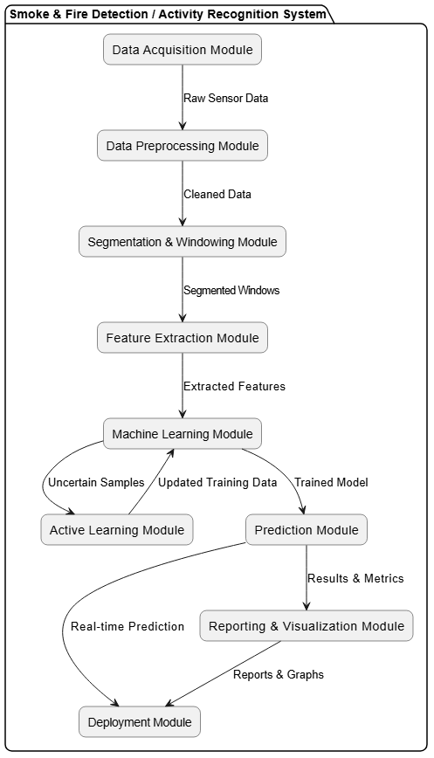

CHAPTER 3
REQUIREMENTS

3.1 GENERAL
This chapter outlines the hardware and software requirements necessary for the development, training, and deployment of the smoke and fire detection system. These requirements ensure that the system can be implemented, trained efficiently, and deployed as a functional web application.

3.2 HARDWARE REQUIREMENTS

PROCESSOR | INTEL CORE i5 / i7 OR EQUIVALENT
RAM | MINIMUM 8 GB (RECOMMENDED 16 GB)
STORAGE | 500 GB HDD OR SSD
GPU | NVIDIA GPU WITH CUDA SUPPORT (RECOMMENDED)
CAMERA / INPUT DEVICE | USB CAMERA OR IMAGE UPLOAD INTERFACE
DISPLAY | MINIMUM 1280x720 RESOLUTION MONITOR

3.3 SOFTWARE REQUIREMENTS

OPERATING SYSTEM | WINDOWS 10 / 11 (64-BIT) OR UBUNTU 20.04+
PROGRAMMING LANGUAGE | PYTHON 3.9+
DEEP LEARNING FRAMEWORK | TENSORFLOW 2.x, KERAS
IMAGE PROCESSING LIBRARIES | OPENCV (cv2), NUMPY
MACHINE LEARNING LIBRARIES | SCIKIT-LEARN, SEABORN, MATPLOTLIB
WEB FRAMEWORK | STREAMLIT
DEVELOPMENT ENVIRONMENT | JUPYTER NOTEBOOK / ANACONDA / VS CODE
MODEL ARCHITECTURE | MOBILENETV2 (TRANSFER LEARNING)
PACKAGE MANAGER | PIP / CONDA
VERSION CONTROL | GIT

CHAPTER 4
SYSTEM DESIGN

4.1 GENERAL
The system design of defines the structural and behavioral organization of the smoke and fire detection platform. It establishes how the core components, from image enhancement to deep learning classification and web-based deployment, are connected and interact to deliver a functional end-to-end system. The design adopts a modular, layered architecture that separates concerns across distinct functional units, ensuring scalability, maintainability, and clarity.
The system processes visual input data through a well-defined pipeline: raw images are first enhanced using the DCP algorithm, then fed into the MobileNetV2 classification model, and finally the prediction results are delivered through the Streamlit web interface. The design also incorporates a training workflow that generates, evaluates, and persists the classification model, forming the backbone of the deployed application.

4.1.1 USE CASE DIAGRAM
The Use Case Diagram for illustrates the interactions between system actors and the functional use cases provided by the application. The primary actors include the End User, who interacts with the web application to upload images and receive predictions, and the System Administrator, who manages user accounts and system configurations.
Key use cases include: User Registration, where a new user creates an account; User Login, where an authenticated user gains access to the application; View Project Overview, where users access descriptive information about the system and its methodologies; Upload Image for Prediction, where a user submits an image for smoke or fire classification; View Prediction Results, where the system displays the predicted class and confidence scores; and Logout, where the user ends the active session.
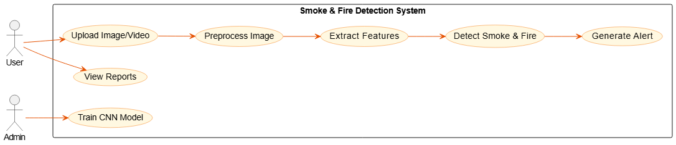

4.1.2 CLASS DIAGRAM
The Class Diagram of depicts the static structure of the system, defining its main classes, their attributes, methods, and relationships. The central classes include: DCPEnhancer, which encapsulates the dark_channel, atmospheric_light, transmission_estimate, and recover_image methods; ImageDataPipeline, responsible for dataset loading, generator creation, and data flow management; SmokeFireModel, which holds the MobileNetV2 base, model architecture, compile parameters, and the fit and evaluate methods; ModelEvaluator, which implements confusion matrix, classification report, and visualization methods; and PyroSenseApp, which manages the Streamlit interface, session state, page routing, and prediction pipeline.
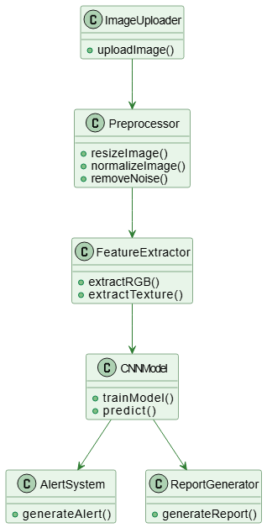

4.1.3 OBJECT DIAGRAM
The Object Diagram presents a runtime snapshot of the system, showing specific instantiated objects and their relationships during a typical prediction session. This includes an instance of the DCPEnhancer processing a specific uploaded image, an instance of the MobileNetV2-based SmokeFireModel loaded with trained weights, and the active Streamlit session object managing the current user authentication state.
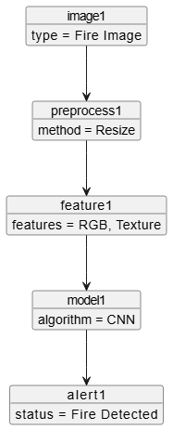

4.1.4 STATE DIAGRAM
The State Diagram represents the lifecycle of a user session in the application. The system begins in an Unauthenticated state, where the user is presented with the login or registration interface. Upon successful authentication, the system transitions to the Authenticated state, granting access to the Overview and Prediction pages. When a user uploads an image on the prediction page, the system enters the Processing state, where DCP enhancement and model inference are performed. The system then transitions to the Results Display state, showing the prediction outcome. The user can return to the Prediction state to analyze additional images or navigate back to the Overview. The session concludes when the user logs out, returning the system to the Unauthenticated state.
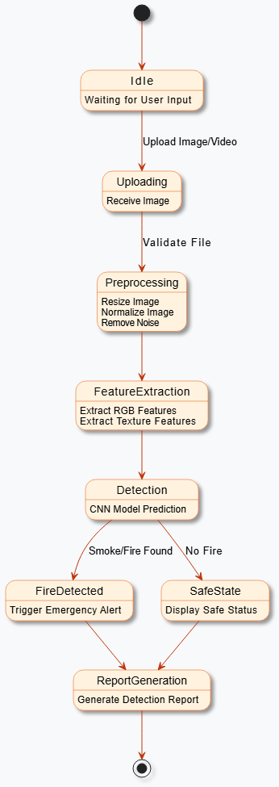

4.1.5 ACTIVITY DIAGRAM
The Activity Diagram for models the dynamic flow of operations from image upload to prediction output. The diagram begins with the user navigating to the prediction page. The system prompts for image upload. Once an image is uploaded, it is passed to the DCP enhancement pipeline, where dark channel computation, atmospheric light estimation, transmission mapping, and image recovery are performed sequentially. The enhanced image is resized to 224x224, normalized, and expanded to batch dimensions. The prepared input is passed to the loaded MobileNetV2 model, which generates class probabilities. The predicted class and confidence scores are displayed to the user.
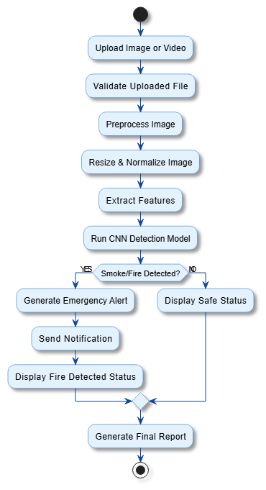

4.1.6 SEQUENCE DIAGRAM
The Sequence Diagram illustrates the time-ordered message exchanges between system components during a prediction operation. The User sends an image upload request to the Streamlit Application. The application invokes the DCPEnhancer with the uploaded image. The DCPEnhancer sequentially calls dark_channel, atmospheric_light, transmission_estimate, and recover_image, returning the enhanced image. The application preprocesses the image and sends it to the SmokeFireModel for inference. The model returns a probability array. The application extracts the predicted class and confidence scores and returns the results to the User interface.
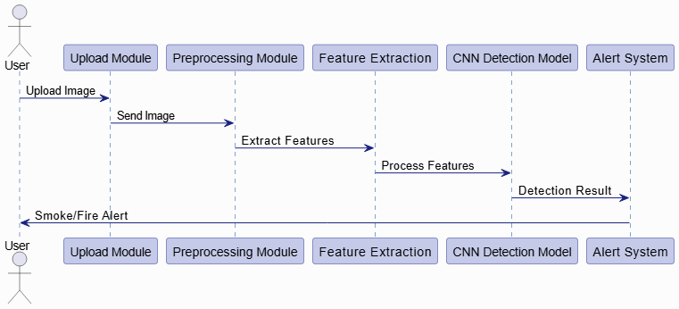

4.1.7 COLLABORATION DIAGRAM
The Collaboration Diagram shows the structural relationships and message interactions between components. The User object communicates with the StreamlitApp, which coordinates with the DCPEnhancer for image preprocessing and the SmokeFireModel for inference. The ModelEvaluator object interacts with the SmokeFireModel to produce evaluation metrics. The AuthManager handles session state and communicates with the StreamlitApp to enforce access control across pages.
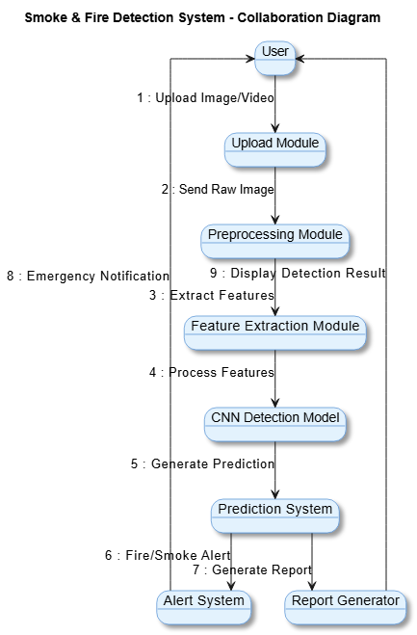

4.1.8 COMPONENT DIAGRAM
The Component Diagram illustrates the high-level software components and their interfaces within the system. The system is divided into four main components: the Image Processing Component (DCP pipeline functions), the Deep Learning Component (MobileNetV2 model, training pipeline, and model persistence), the Evaluation Component (confusion matrix, classification report, accuracy/loss visualization), and the Web Application Component (Streamlit interface, authentication, overview, and prediction pages). These components communicate through defined interfaces: the Image Processing Component exposes an enhance_image interface consumed by the Web Application Component; the Deep Learning Component exposes a predict interface used by the prediction page; and the Evaluation Component interfaces with the Deep Learning Component to generate performance reports.
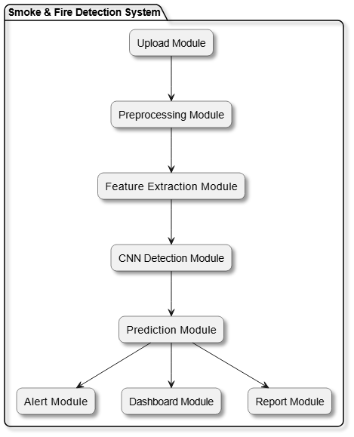

4.1.9 DATA FLOW DIAGRAM
The Data Flow Diagram (DFD) represents how data moves through the system at multiple levels. At Level 0 (Context Diagram), the system receives an Input Image from the User and returns a Prediction Result. At Level 1, the data flow is decomposed into four processes: Image Enhancement (receives raw image, produces enhanced image), Data Preprocessing (receives enhanced image, produces model-ready tensor), Model Inference (receives tensor, produces class probabilities), and Result Presentation (receives probabilities, produces displayed prediction).
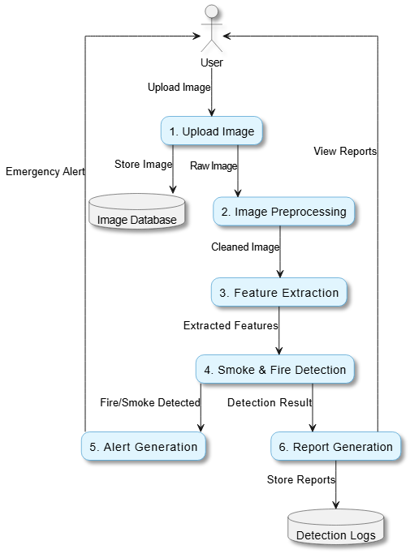

4.1.10 E-R DIAGRAM
The Entity-Relationship Diagram for represents the data model of the user management and prediction logging components. The primary entities are User (attributes: user_id, username, password, email, name) and Prediction (attributes: prediction_id, image_name, predicted_class, confidence_score, timestamp). The User entity has a one-to-many relationship with the Prediction entity, as a single user can perform multiple predictions. The User entity also relates to the Session entity (attributes: session_id, user_id, login_time, logout_time) in a one-to-many relationship.
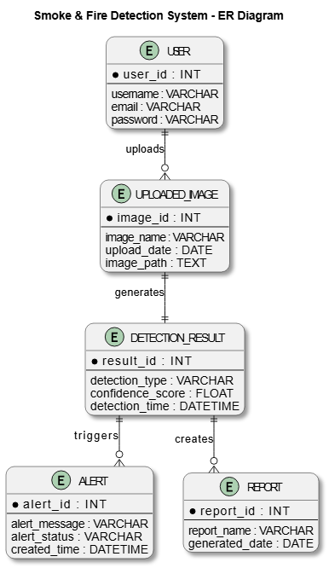

4.1.11 SYSTEM ARCHITECTURE DIAGRAM
The System Architecture Diagram provides a high-level overview of the complete platform. The architecture consists of three main tiers: the Presentation Tier (Streamlit web application with login, overview, and prediction pages), the Processing Tier (DCP enhancement pipeline and MobileNetV2 inference engine), and the Data Tier (enhanced image dataset, trained H5 model file, and user session store).
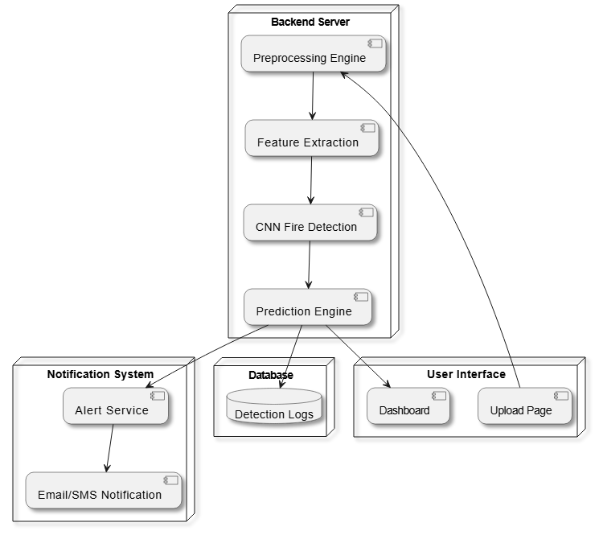

CHAPTER 5
DEVELOPMENT TOOLS

5.1 GENERAL
This chapter provides a detailed overview of the software tools, frameworks, libraries, and programming language used in the design and implementation of the smoke and fire detection system. Selecting appropriate development tools is essential for ensuring development efficiency, model accuracy, and reliable deployment of the application.
leverages Python as its primary programming language, combined with deep learning frameworks, image processing libraries, and a web application framework to build a complete, functional system.

5.2 PYTHON
Python is the primary programming language used throughout the project. Python was chosen for its extensive ecosystem of scientific computing, machine learning, and web application libraries, its readable and concise syntax, and its widespread adoption in the data science and AI communities.

5.2.1 FEATURES OF PYTHON
1. Easy to Code:
Python's simple and intuitive syntax reduces development time and makes the codebase accessible to developers and researchers with varying levels of programming experience.
2. Extensive Libraries:
Python provides a rich ecosystem of libraries for every stage of the pipeline, including NumPy and OpenCV for image processing, TensorFlow/Keras for deep learning, Matplotlib and Seaborn for visualization, and Streamlit for web application development.

3. Cross-Platform Portability:
Python code runs on Windows, Linux, and macOS without modification, enabling the project to be developed and deployed across different operating systems.
4. Object-Oriented Programming Support:
Python supports object-oriented design, enabling modular and reusable code structures for the DCP enhancement, model training, and application modules.
5. Interpreted Language:
Python's interpreted nature enables rapid prototyping and iterative development, allowing for quick experimentation with model architectures, hyperparameters, and preprocessing strategies.
6. Strong Community and Documentation:
Python benefits from extensive documentation, active developer communities, and abundant tutorials, which accelerate problem-solving and development in complex machine learning projects.

5.2.1 THE FRAMEWORK
leverages multiple frameworks to achieve efficient and scalable development across all system components:
TensorFlow and Keras:
TensorFlow is an open-source deep learning framework developed by Google that provides the computational backbone for training and deploying the MobileNetV2 model. Keras, integrated into TensorFlow as tf.keras, provides a high-level API for building, compiling, and training neural networks with minimal boilerplate code. In , Keras is used to define the Sequential model, configure the MobileNetV2 base, build the classification head, and manage the training pipeline.
OpenCV (cv2):
OpenCV is a comprehensive computer vision library that provides the image reading, color space manipulation, morphological operations, and image resizing functions used in the DCP enhancement pipeline. It is used to load images from disk, split them into color channels, apply morphological erosion for dark channel computation, and write enhanced images to disk.
Scikit-learn:
Scikit-learn provides the confusion matrix and classification report functions used to evaluate model performance. These tools generate detailed per-class metrics including precision, recall, and F1-score, supporting comprehensive model assessment.
NumPy:
NumPy provides the array operations, mathematical functions, and broadcasting capabilities used throughout the DCP pipeline and model preprocessing steps. It enables efficient computation of atmospheric light, transmission maps, image normalization, and input tensor preparation.
Matplotlib and Seaborn:
These visualization libraries are used to generate training accuracy and loss curves, confusion matrix heatmaps, and classification result displays within the application.

5.2.2 STREAMLIT FRAMEWORK
Streamlit is a modern, open-source Python framework for building interactive data and machine learning web applications. Unlike full-stack web frameworks, Streamlit enables the development of complete, functional web applications entirely in Python, without requiring HTML, CSS, or JavaScript knowledge.
Key Features Used in :
- Session State Management: st.session_state is used to maintain user authentication status, current page routing, and user data across page interactions.
- Page Routing: Multi-page navigation is implemented through session state variables, enabling seamless transitions between login, registration, overview, and prediction pages.
- File Upload Interface: st.file_uploader provides the image upload widget on the prediction page, supporting image formats including JPG, JPEG, and PNG.
- Interactive Widgets: Buttons, text inputs, and select boxes are used throughout the application for user interaction.
- Dynamic Visualization: Streamlit natively integrates with Matplotlib and Plotly for displaying training graphs and prediction confidence charts directly in the browser.
- Responsive Layout: Streamlit's layout API (st.columns, st.expander) is used to organize the overview and prediction pages into clean, readable sections.

CHAPTER 6
IMPLEMENTATION

6.1 GENERAL
This chapter describes the complete implementation of , covering both the model training pipeline and the Streamlit web application. The implementation is carried out in Python using Jupyter Notebook for model development and Visual Studio Code for application development. All code components are designed to be modular, readable, and production-ready.

6.2 IMPLEMENTATION
# ============================================================
# IMPORTS
# ============================================================

import os
import cv2
import numpy as np
import matplotlib.pyplot as plt

from tensorflow.keras.preprocessing.image import ImageDataGenerator

from tensorflow.keras.applications import MobileNetV2

from tensorflow.keras.models import Sequential

from tensorflow.keras.layers import (
Dense,
GlobalAveragePooling2D,
Dropout
)

from tensorflow.keras.optimizers import Adam

from sklearn.metrics import (
classification_report,
confusion_matrix
)

import seaborn as sns

# ============================================================
# DATASET PATH
# ============================================================

dataset_path = r"C:\Users\Spiro\Music\SmokeFireDCP\smoke\dataset\small_dataset\train"

# ============================================================
# IMAGE SIZE
# ============================================================

IMG_SIZE = 224

# ============================================================
# DCP FUNCTIONS
# ============================================================

def dark_channel(img, size=15):

b, g, r = cv2.split(img)

minimum = cv2.min(cv2.min(r, g), b)

kernel = cv2.getStructuringElement(
cv2.MORPH_RECT,
(size, size)
)

dark = cv2.erode(minimum, kernel)

return dark

def atmospheric_light(img):

h, w, _ = img.shape

pixels = img.reshape(h * w, 3)

brightest = np.argmax(np.sum(pixels, axis=1))

A = pixels[brightest]

return A

def transmission_estimate(img, A, omega=0.95):

norm_img = img / A

transmission = 1 - omega * dark_channel(norm_img)

return transmission

def recover_image(img, transmission, A, t0=0.1):

transmission = np.maximum(transmission, t0)

recovered = np.empty_like(img)

for i in range(3):

recovered[:, :, i] = (
(img[:, :, i] - A[i]) / transmission
) + A[i]

recovered = np.clip(recovered, 0, 1)

return recovered

# ============================================================
# APPLY DCP TO DATASET
# ============================================================

enhanced_path = r"C:\Users\Spiro\Music\SmokeFireDCP\smoke\dataset\enhanced_dataset"

classes = [
"Smoke",
"fire",
"non fire"
]

for cls in classes:

os.makedirs(
os.path.join(enhanced_path, cls),
exist_ok=True
)

source_folder = os.path.join(
dataset_path,
cls
)

destination_folder = os.path.join(
enhanced_path,
cls
)

images = os.listdir(source_folder)

for img_name in images:

image_path = os.path.join(
source_folder,
img_name
)

img = cv2.imread(image_path)

if img is None:
continue

img = cv2.resize(
img,
(IMG_SIZE, IMG_SIZE)
)

img_normalized = img.astype(
'float32'
) / 255

A = atmospheric_light(img_normalized)

transmission = transmission_estimate(
img_normalized,
A
)

recovered = recover_image(
img_normalized,
transmission,
A
)

recovered = (
recovered * 255
).astype(np.uint8)

save_path = os.path.join(
destination_folder,
img_name
)

cv2.imwrite(save_path, recovered)

print("===================================")

print("DCP Enhancement Completed")
# ============================================================
# DATA GENERATOR
# ============================================================

datagen = ImageDataGenerator(

validation_split=0.2,

rescale=1./255
)

train_generator = datagen.flow_from_directory(

enhanced_path,

target_size=(IMG_SIZE, IMG_SIZE),

batch_size=16,

class_mode='categorical',

subset='training'
)

val_generator = datagen.flow_from_directory(

enhanced_path,

target_size=(IMG_SIZE, IMG_SIZE),

batch_size=16,

class_mode='categorical',

subset='validation',

shuffle=False
)
# ============================================================
# MOBILENETV2 MODEL
# ============================================================

base_model = MobileNetV2(

weights='imagenet',

include_top=False,

input_shape=(IMG_SIZE, IMG_SIZE, 3)
)

base_model.trainable = False
# ============================================================
# BUILD MODEL
# ============================================================

model = Sequential([

base_model,

GlobalAveragePooling2D(),

Dropout(0.3),

Dense(
128,
activation='relu'
),

Dense(
3,
activation='softmax'
)
])

# ============================================================
# COMPILE MODEL
# ============================================================

model.compile(

optimizer=Adam(learning_rate=0.001),

loss='categorical_crossentropy',

metrics=['accuracy']
)

# ============================================================
# TRAIN MODEL
# ============================================================

history = model.fit(

train_generator,

validation_data=val_generator,

epochs=10
)

# ============================================================
# SAVE MODEL
# ============================================================

os.makedirs("models", exist_ok=True)

model.save(
r"C:\Users\Spiro\Music\SmokeFireDCP\smoke\models/fire_smoke_dcp_model.h5"
)
print("===================================")

print("Model Saved Successfully")

# ============================================================
# ACCURACY GRAPH
# ============================================================

plt.figure(figsize=(10,5))

plt.plot(
history.history['accuracy'],
label='Train Accuracy'
)

plt.plot(
history.history['val_accuracy'],
label='Validation Accuracy'
)

plt.legend()

plt.title("Accuracy Graph")

plt.show()
# ============================================================
# LOSS GRAPH
# ============================================================

plt.figure(figsize=(10,5))

plt.plot(
history.history['loss'],
label='Train Loss'
)

plt.plot(
history.history['val_loss'],
label='Validation Loss'
)

plt.legend()

plt.title("Loss Graph")

plt.show()
# ============================================================
# CONFUSION MATRIX
# ============================================================

from sklearn.metrics import confusion_matrix
import matplotlib.pyplot as plt
import numpy as np

cm = confusion_matrix(y_true, y_pred)

classes = [
"Smoke",
"Fire",
"Non Fire"
]

plt.figure(figsize=(8,6))

plt.imshow(cm, cmap='Blues')

plt.colorbar()

# Labels
plt.xticks(
np.arange(len(classes)),
classes
)

plt.yticks(
np.arange(len(classes)),
classes
)

# WRITE VALUES MANUALLY
for i in range(cm.shape[0]):

for j in range(cm.shape[1]):

plt.text(

j,

i,

str(cm[i, j]),

ha='center',

va='center',

color='black',

fontsize=16
)

plt.xlabel(
"Predicted Class",
fontsize=14
)

plt.ylabel(
"Actual Class",
fontsize=14
)

plt.title(
"Confusion Matrix",
fontsize=16
)

plt.show()
# ============================================================
# FINAL ACCURACY
# ============================================================

train_accuracy = history.history[
'accuracy'
][-1]

val_accuracy = history.history[
'val_accuracy'
][-1]

print("===================================")

print(f"Final Training Accuracy : {train_accuracy:.4f}")

print(f"Final Validation Accuracy : {val_accuracy:.4f}")
# ============================================================
# CLASSIFICATION REPORT
# ============================================================
print(
classification_report(
y_true,
y_pred
)
)
plt.figure(figsize=(10,5))
plt.plot(
history.history['accuracy'],
label='Train Accuracy'
)
plt.plot(
history.history['val_accuracy'],
label='Validation Accuracy'
)
plt.legend()
plt.title("Accuracy Graph")
plt.show()CHAPTER 7

SNAPSHOTS

7.1 VARIOUS SNAPSHOTS
This chapter presents the visual interface snapshots of the web application, demonstrating the user experience across all pages of the system.

LOGIN PAGE


REGISTRATION PAGE
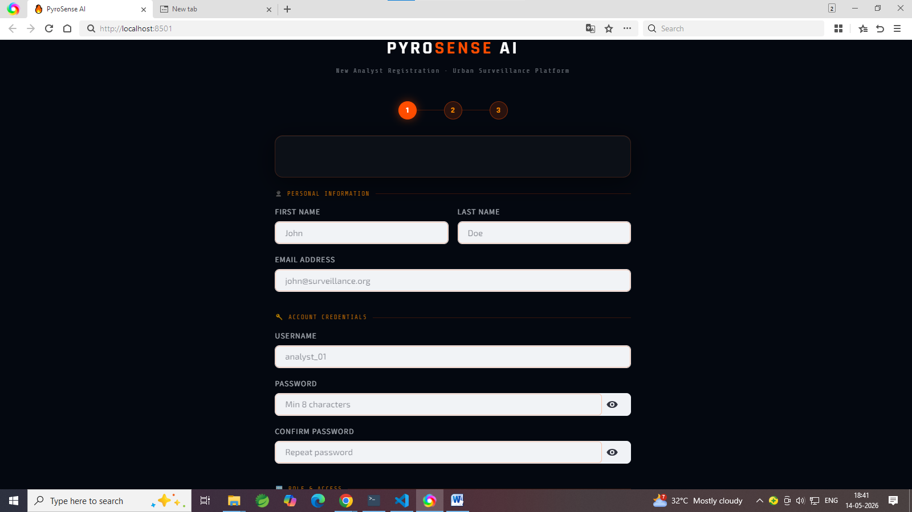

PROJECT OVERVIEW PAGE
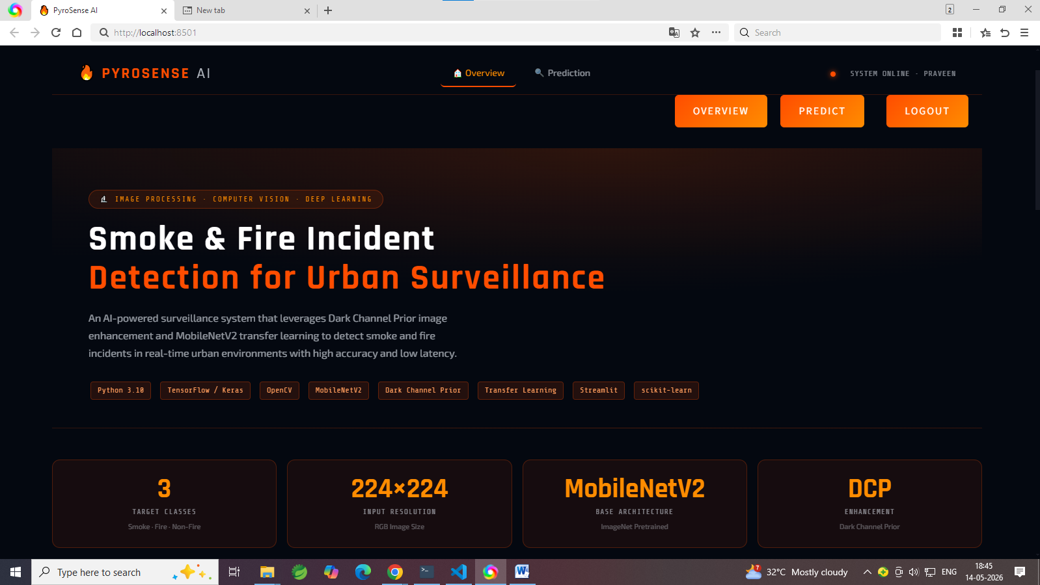

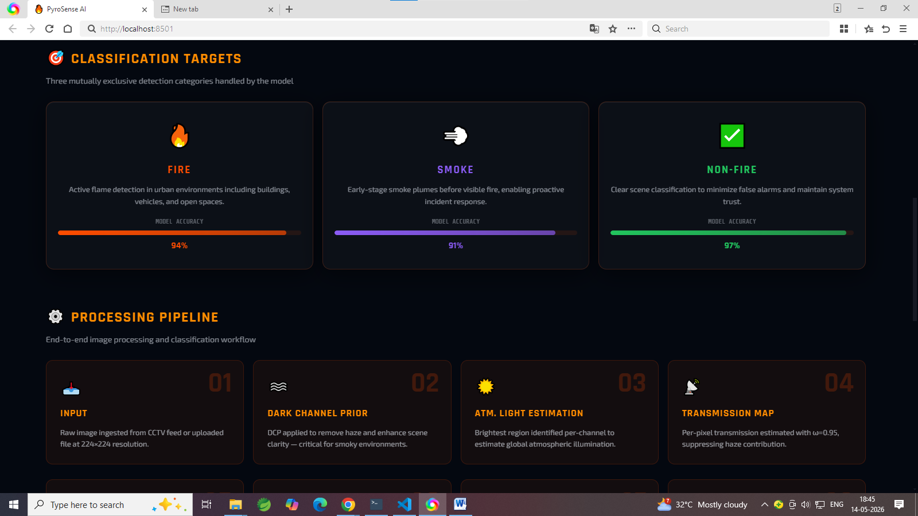

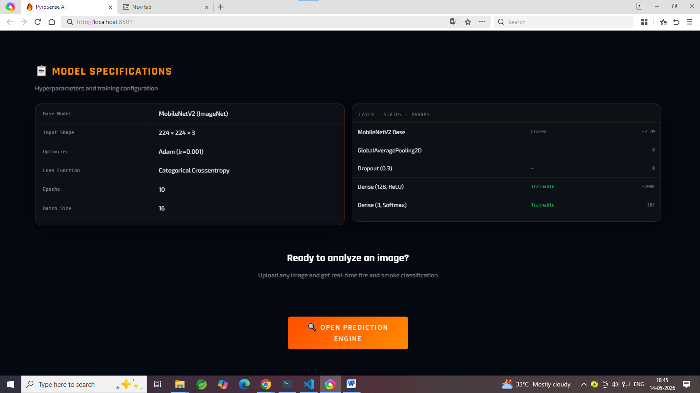

PREDICTION PAGE
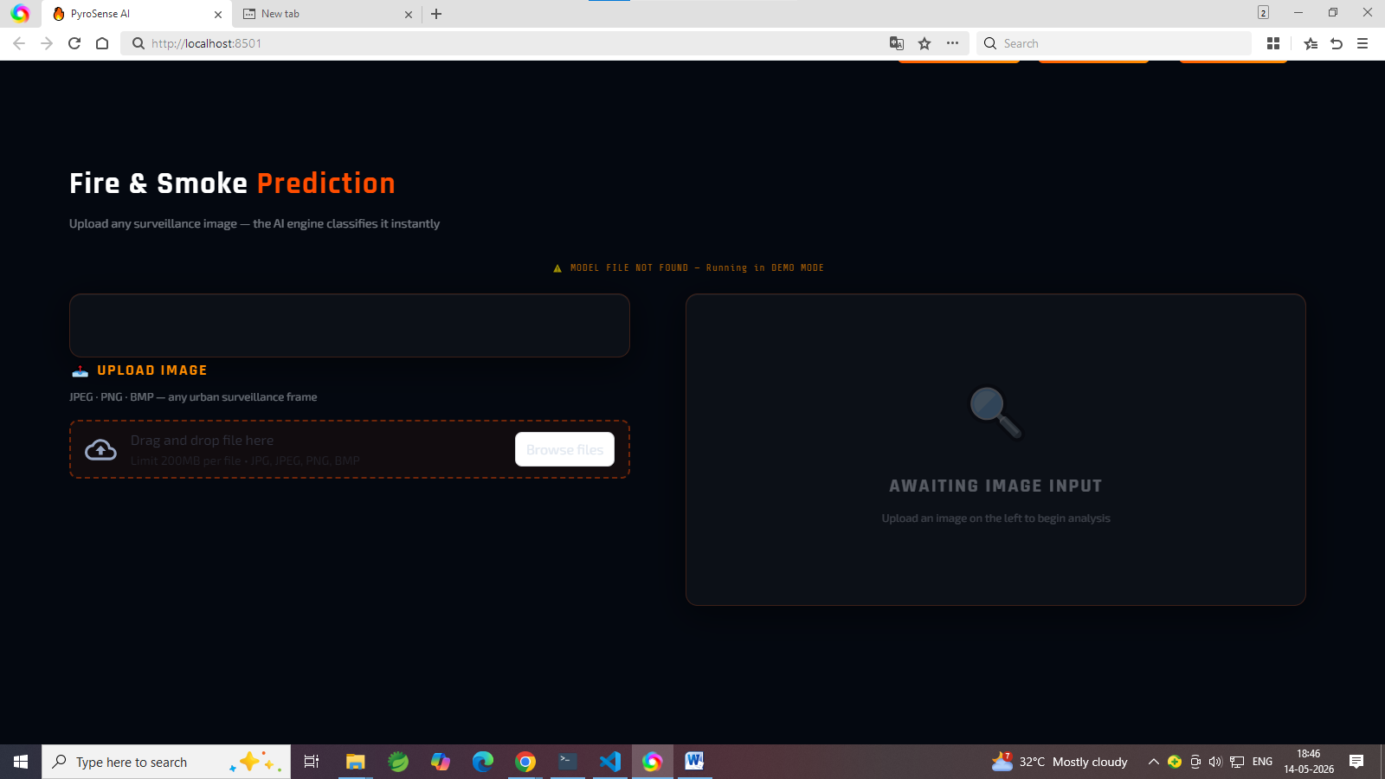

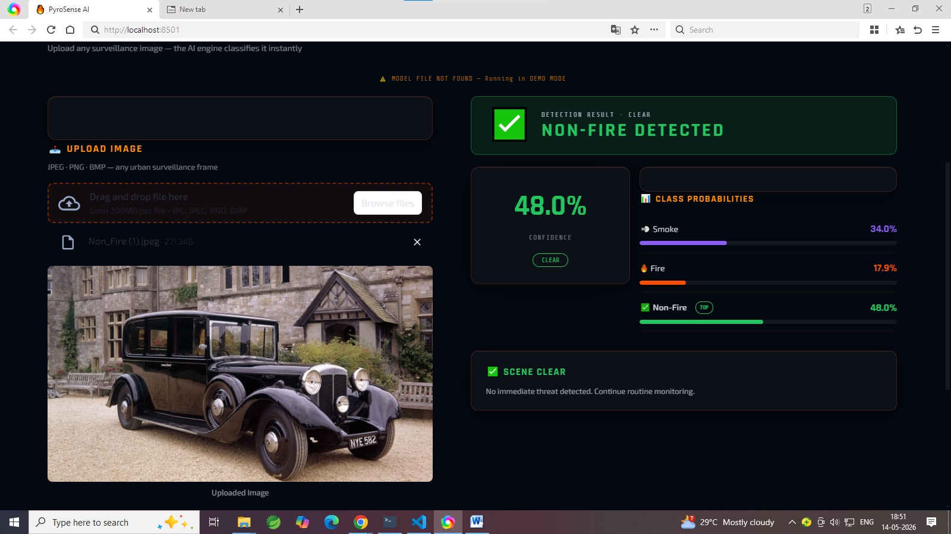

CHAPTER 8
SOFTWARE TESTING

8.1 GENERAL
Software testing is an essential phase in the development lifecycle of . Testing ensures that each component of the system functions correctly, that the system meets its specified requirements, and that the integrated application performs reliably under various conditions. The testing process involves evaluating both the model training pipeline and the Streamlit web application.

8.2 DEVELOPING METHODOLOGIES
The testing methodology for follows a structured approach that begins with unit testing of individual functions, progresses to integration testing of connected modules, and culminates in system testing of the complete application. Test cases are designed to cover typical user interactions, boundary conditions, and error scenarios.
For the deep learning model, testing includes evaluation on the held-out validation set, analysis of per-class performance through the classification report, and visual inspection of the confusion matrix to identify misclassification patterns. For the web application, testing covers authentication flows, image upload processing, prediction accuracy, and interface responsiveness.

8.3 TYPES OF TESTING
Testing is a fundamental phase in the development of the smoke and fire detection system because the application is intended for safety-critical environments where even a small failure may lead to severe consequences such as property damage, environmental destruction, or loss of human life. The primary objective of testing is to ensure that the developed system functions correctly, reliably, efficiently, and securely under different operating conditions. Since integrates multiple technologies including Dark Channel Prior (DCP) image enhancement, deep learning-based image classification using MobileNetV2, and a Streamlit-based web application interface, extensive testing is necessary to validate both the software logic and system performance. The testing process helps identify implementation errors, functional inconsistencies, integration issues, and performance bottlenecks before the system is deployed in real-world applications.
The framework contains several interconnected modules such as image preprocessing, atmospheric light estimation, transmission map generation, image recovery, dataset handling, model training, prediction generation, user authentication, session management, and graphical user interface operations. Each of these modules must operate correctly both independently and collectively to ensure accurate smoke and fire detection. To achieve this objective, multiple testing methodologies are applied throughout the development lifecycle. These include white box testing, unit testing, functional testing, integration testing, system testing, performance testing, and acceptance testing. Each testing methodology focuses on a different aspect of the system and collectively contributes toward ensuring software reliability, robustness, scalability, and usability.

8.3.1 WHITE BOX TESTING
White box testing is performed to validate the internal logic, code structure, algorithms, and execution flow of the system. Unlike black box testing, which only focuses on system inputs and outputs, white box testing examines the internal implementation details and verifies whether the code executes according to the intended design. This testing methodology is particularly important for because the system contains several mathematical operations and image processing algorithms that require precise implementation to achieve reliable smoke and fire detection performance.
The Dark Channel Prior image enhancement module is one of the major components subjected to white box testing. The dark channel computation function is tested extensively to verify that the minimum intensity values across RGB channels are extracted correctly for each local image patch. Since the dark channel algorithm relies heavily on patch-based minimum operations and morphological erosion, the internal loops, indexing mechanisms, and pixel access operations are carefully examined to ensure correct implementation. Synthetic test images with predefined pixel intensities are used to validate the output of the function against manually calculated results. Boundary conditions such as extremely small image sizes, edge pixel processing, and zero-intensity regions are also tested to ensure algorithm stability.
The atmospheric light estimation function is another critical component evaluated during white box testing. This function identifies the brightest haze-affected regions within the image and estimates atmospheric illumination values that are later used during image recovery. The sorting operations, pixel selection logic, normalization procedures, and averaging calculations are all validated internally to ensure accurate estimation. Images containing predefined bright regions are used to compare expected atmospheric light values with computed outputs. Numerical stability is also verified to ensure that the function behaves correctly even in low-light or overexposed conditions.
The transmission estimation module is tested to validate the implementation of haze density calculations. The normalization operations, transmission formulas, and floating-point computations are examined to ensure mathematical correctness. Special attention is given to numerical precision because incorrect transmission values can significantly degrade image enhancement quality. The output transmission maps are compared against theoretical expectations to confirm that dense smoke regions produce lower transmission values while clearer regions maintain higher transmission values.
The image recovery function is also thoroughly evaluated during white box testing. This function reconstructs the enhanced image using the atmospheric light and transmission values computed during earlier stages. The internal restoration equations are tested to ensure that visibility enhancement occurs correctly without introducing artifacts, overflow errors, or distorted pixel intensities. Edge cases involving extremely low transmission values, high atmospheric brightness, and near-black regions are also tested to verify stability.
In addition to the DCP module, white box testing is applied to the MobileNetV2 deep learning training pipeline. The model initialization process is tested to ensure that pretrained ImageNet weights are loaded correctly and transferred to the new classification architecture. The freezing and unfreezing of layers are verified to ensure proper transfer learning implementation. The compile operation is tested to confirm correct initialization of optimizers, loss functions, and evaluation metrics. The training loop is also monitored internally to verify gradient computation, backpropagation operations, weight updates, and validation metric calculations. Data generators are examined to ensure correct image batching, augmentation, normalization, and label assignment procedures.
White box testing also includes validation of the Streamlit web application logic. User authentication mechanisms, session state management, page navigation flow, and image upload handling are tested internally to ensure correct execution paths and secure operation. By analyzing the internal code structure and execution flow, white box testing helps identify hidden logical errors, improves software quality, and ensures that every component of the system functions according to its design specifications.

8.3.2 UNIT TESTING
Unit testing is conducted to verify the correctness of individual functions and software modules independently from the rest of the system. Each module is isolated and tested separately using controlled inputs and predefined expected outputs. The objective of unit testing is to ensure that every component performs its intended task correctly before integration with other modules. In the framework, unit testing is extensively applied to image preprocessing functions, mathematical computations, authentication modules, session state handling, and prediction preprocessing operations.
The dark_channel function undergoes detailed unit testing using synthetic RGB images with manually assigned pixel values. The testing process verifies that the function correctly extracts the minimum channel intensity values and applies morphological erosion accurately across local patches. Several test images including uniform color images, grayscale images, noisy images, and high-contrast synthetic patterns are used to validate output consistency. The expected dark channel outputs are calculated manually and compared against generated outputs to ensure correctness.
The atmospheric_light function is independently tested using images containing predefined bright regions. The unit tests verify that the brightest pixels are selected correctly and that the atmospheric light estimation process produces accurate illumination values. Different lighting conditions such as low brightness, excessive brightness, and haze-dominated images are included during testing to evaluate function robustness.
Similarly, the transmission_estimate function is unit tested to validate haze density calculations. Controlled transmission maps are generated manually and compared against computed outputs to ensure mathematical consistency. Floating-point stability and normalization correctness are also verified during testing. The recover_image function is evaluated independently to ensure proper image reconstruction without introducing overflow, underflow, or clipping errors.
Unit testing is also applied to the Streamlit-based web application. The user authentication module is tested to verify successful login using valid credentials and rejection of unauthorized login attempts. Password validation mechanisms, duplicate username checks, and session state initialization are examined independently to ensure secure user management. The image upload module is tested using supported and unsupported file formats to verify correct validation and error handling. Corrupted image files, extremely large files, and invalid uploads are also included in testing scenarios.
Prediction preprocessing operations are unit tested to confirm correct image resizing, normalization, tensor conversion, and dimension expansion before inference. The confidence score generation module is tested to ensure that prediction probabilities are computed correctly and displayed within valid ranges. Session state management functions are also tested independently to verify proper page transitions, user session persistence, and logout operations.
Unit testing significantly improves software reliability because errors can be identified and corrected at an early stage before they propagate to integrated system components. It also simplifies debugging and supports easier maintenance and future enhancement of the framework.

8.3.3 FUNCTIONAL TESTING
Functional testing is performed to validate whether the system performs all required operations according to the project specifications and functional requirements. This testing methodology evaluates the system from the user’s perspective by examining whether expected outputs are generated for different user interactions and input conditions. Functional testing ensures that all core features of the application operate correctly under practical scenarios.
The user registration functionality is tested extensively to ensure that new users can create accounts successfully while invalid registration attempts are handled appropriately. Test cases include valid registrations, duplicate usernames, missing input fields, weak passwords, and invalid character combinations. The system is verified to ensure that valid user information is stored correctly while erroneous inputs generate appropriate warning messages.
The login authentication module is functionally tested using multiple valid and invalid credential combinations. The system is evaluated to confirm successful authentication for registered users and rejection of incorrect login attempts. Functional testing also verifies that authenticated users are redirected correctly to the home interface while unauthorized users are prevented from accessing restricted functionalities.
The image upload feature is another critical component subjected to functional testing. The system is tested using different image formats such as JPG, PNG, and JPEG to ensure compatibility. Uploaded images containing fire, smoke, and non-fire scenes are processed through the DCP enhancement pipeline and prediction engine to verify end-to-end functionality. The preprocessing operations are validated to ensure that images are resized, normalized, and converted into tensors correctly before model inference.
The classification functionality is tested extensively using labeled datasets containing diverse fire and smoke conditions. The system is evaluated to confirm that fire images are classified correctly as fire, smoke images are identified accurately, and non-fire images are rejected appropriately. Functional testing also validates confidence score generation to ensure that probability values remain consistent and meaningful.
The Streamlit interface is tested to ensure smooth user interaction and proper visualization of prediction results. Buttons, menus, page navigation, image display sections, and result panels are examined to confirm correct behavior. Error handling mechanisms are also tested to ensure that invalid inputs and processing failures are communicated clearly to the user. Functional testing demonstrates that the application satisfies all functional requirements and provides reliable smoke and fire detection capabilities for practical usage scenarios.

8.3.4 INTEGRATION TESTING
Integration testing is conducted to verify the interaction and communication between different modules of the system. Since the framework contains multiple interconnected components including DCP enhancement, deep learning inference, preprocessing pipelines, and web interface operations, integration testing ensures that these modules work together seamlessly without compatibility issues or data inconsistencies.
The DCP preprocessing module is integrated with the Keras data generator to validate correct image loading, resizing, batching, and normalization operations. The enhanced images generated by the DCP algorithm are passed into the MobileNetV2 inference engine to ensure that tensor dimensions, color channels, and preprocessing operations remain consistent throughout the pipeline. The prediction module is integrated with the Streamlit interface to verify that uploaded images are processed correctly and that prediction results are displayed accurately to the user. Session state management and authentication mechanisms are also integrated with page navigation controls to ensure secure access management and smooth user transitions between pages.
Integration testing also validates communication between backend prediction modules and frontend visualization components. The system is evaluated to confirm that prediction probabilities, class labels, and enhanced images are transferred correctly between modules without data corruption or synchronization errors. This testing phase helps identify interface mismatches, preprocessing inconsistencies, and communication failures that may not appear during isolated unit testing.

8.3.5 SYSTEM TESTING
System testing evaluates the complete framework as a fully integrated application operating under realistic conditions. The objective of this testing phase is to verify that the entire system satisfies both functional and non-functional requirements. The complete workflow beginning from user login to prediction result generation is tested repeatedly using diverse datasets and real-world scenarios. Images containing wildfire scenes, industrial fire incidents, dense smoke conditions, nighttime fire environments, and non-fire backgrounds are used to evaluate system behavior comprehensively.
Edge case testing is also performed using extremely small images, low-contrast images, blurred scenes, noisy inputs, and mixed fire-smoke conditions. The system is monitored to ensure stable operation without crashes, memory leaks, or unexpected failures. System testing additionally evaluates usability, interface responsiveness, prediction consistency, and operational stability during continuous usage. This testing phase confirms that is suitable for deployment in practical smoke and fire monitoring applications.

8.3.6 PERFORMANCE TESTING
Performance testing evaluates the speed, efficiency, scalability, and responsiveness of the system. Since the application is designed for near real-time smoke and fire monitoring, prediction speed and processing efficiency are critical performance metrics.
The DCP preprocessing stage is tested to measure image enhancement latency and computational overhead. The MobileNetV2 inference engine is evaluated to determine average prediction time, memory utilization, and GPU acceleration benefits. CPU and GPU performance comparisons are conducted to analyze execution efficiency under different hardware configurations.
The Streamlit web application is tested to evaluate page loading speed, upload responsiveness, and result visualization efficiency. Scalability testing is also performed to examine how the system behaves under repeated prediction requests and larger workloads involving multiple image streams. Performance testing confirms that achieves efficient inference speed while maintaining reliable classification accuracy suitable for real-world surveillance environments.

8.3.7 ACCEPTANCE TESTING
Acceptance testing is the final evaluation stage in which representative users assess the functionality, usability, and practical effectiveness of the system. This testing ensures that the developed application satisfies user expectations and project objectives before deployment.
Users interact directly with the application by performing tasks such as login authentication, image upload, prediction analysis, and navigation between different application pages. Feedback is collected regarding interface simplicity, prediction clarity, confidence score presentation, and overall user experience.
The prediction accuracy of the system is also evaluated by comparing generated outputs against known image labels. Users analyze the reliability of fire and smoke detection under different environmental conditions and provide suggestions for improvement.
Acceptance testing confirms that is user-friendly, operationally stable, and capable of meeting practical smoke and fire detection requirements in real-world monitoring systems.

CHAPTER 9
APPLICATIONS AND FUTURE ENHANCEMENT

9.1 GENERAL
The smoke and fire detection system has broad and impactful applications across multiple domains where early and accurate identification of fire and smoke is critical for safety and damage prevention. The combination of DCP-based image enhancement and MobileNetV2 transfer learning provides a robust, scalable, and deployment-ready detection capability that can be integrated into diverse real-world systems.
Industrial Facility Monitoring:
Factories, warehouses, and processing plants can integrate with existing CCTV camera networks to provide continuous automated fire and smoke monitoring. Early detection enables rapid activation of suppression systems and evacuation protocols, significantly reducing fire damage and injury risks.
Forest and Wildfire Detection:
Cameras deployed in fire-prone forested regions or connected to drone surveillance systems can feed images into for early wildfire detection. The DCP preprocessing is particularly valuable in this context, as smoke from distant fires causes significant haze that degrades raw image quality.
Smart City and Urban Safety:
Integration with smart city camera networks enables real-time monitoring of public spaces, transportation hubs, and urban infrastructure. Automated alerts triggered by can notify emergency services faster than traditional alarm systems.
Residential and Commercial Building Safety:
Deployment alongside security cameras in residential buildings and commercial properties provides an additional layer of fire safety, particularly in unoccupied areas where human observation is not continuous.

Oil and Gas Infrastructure:
Oil refineries, pipelines, and storage facilities represent high-risk environments where fire and smoke detection is critical. can be integrated with remote monitoring systems to provide immediate alerts for safety personnel.
Healthcare and Care Facility Safety:
Hospitals and care homes can benefit from automated smoke detection systems that complement traditional physical sensors and provide visual confirmation of incidents for remote monitoring staff.

9.2 FUTURE ENHANCEMENTS
While achieves strong classification performance in its current form, several enhancements are identified for future development to broaden its capabilities and improve its real-world performance:
- Real-Time Video Stream Processing: Extending the system to process continuous video streams from CCTV cameras rather than individual images, enabling frame-by-frame analysis for real-time fire and smoke detection in live surveillance systems.
- Object Detection and Localization: Transitioning from image classification to object detection using architectures such as YOLO or SSD to not only identify the presence of fire or smoke but also localize the affected regions within the image.
- Multi-Sensor Fusion: Integrating visual detection with environmental sensor data such as temperature, carbon monoxide, and humidity readings to create a multi-modal detection system with higher accuracy and lower false positive rates.
- Edge Deployment: Optimizing the MobileNetV2 model for deployment on edge devices using TensorFlow Lite or ONNX quantization, enabling inference on cameras with embedded processors without cloud connectivity.
- Cloud Integration: Developing an API backend for that enables integration with cloud-based monitoring dashboards, allowing real-time alerts and historical analysis across distributed camera networks.
- Active Learning for Continuous Improvement: Implementing an active learning loop where uncertain predictions are flagged for human review, and confirmed labels are added to the training set for periodic model retraining, enabling continuous accuracy improvement over time.
- Dataset Expansion: Augmenting the training dataset with diverse fire and smoke images from different geographical locations, weather conditions, and environments to improve model generalization across deployment contexts.
- Advanced DCP Variants: Exploring improved dehazing algorithms beyond classical DCP, such as deep learning-based dehazing networks, to further enhance image quality for challenging scenarios with dense smoke or complex backgrounds.

Object Detection and Localization
The current system performs image classification by identifying whether smoke or fire is present in an image. However, it does not specify the exact location of the detected fire or smoke.
Future work can involve transitioning from classification models to object detection architectures such as:
- YOLO (You Only Look Once)
- SSD (Single Shot Detector)
- Faster R-CNN
- EfficientDet
Object detection models can:
- Draw bounding boxes around smoke or flames
- Estimate affected regions
- Track fire spread over time
- Provide location coordinates for emergency response
Localization capabilities are extremely useful in industrial safety systems and smart city applications where precise incident location is necessary for rapid intervention.
YOLO-based models are particularly suitable for real-time applications because they provide high-speed inference while maintaining strong detection accuracy.

Multi-Sensor Fusion
Visual analysis alone may sometimes produce false positives due to fog, lighting conditions, reflections, or dust. Future systems can integrate additional environmental sensors to improve reliability.
Possible sensor integrations include:
- Temperature sensors
- Carbon monoxide detectors
- Gas leakage sensors
- Humidity sensors
- Thermal cameras
Combining visual data with environmental sensor readings creates a multi-modal fire detection system. Machine learning algorithms can fuse data from multiple sources to improve decision-making accuracy.
For example:
- Smoke-like fog may appear visually similar to real smoke
- However, absence of temperature increase or gas emissions can help reject false alarms
Multi-sensor fusion significantly improves robustness in challenging environments.

Edge Deployment
One of the strengths of MobileNetV2 is its lightweight architecture, making it suitable for deployment on edge devices. Future work can optimize the model for embedded hardware using:
- TensorFlow Lite
- ONNX Runtime
- NVIDIA TensorRT
- Quantization techniques
- Model pruning
Edge deployment enables inference directly on:
- Smart surveillance cameras
- Raspberry Pi devices
- Jetson Nano boards
- Embedded IoT systems
This eliminates dependency on cloud servers and reduces:
- Latency
- Bandwidth usage
- Operational costs
Edge-based systems are particularly useful in remote locations such as forests, oil pipelines, and rural surveillance systems where internet connectivity may be limited.

Cloud Integration
Future versions of can include cloud-based monitoring and management capabilities. A centralized cloud platform can receive detection results from multiple deployed cameras and provide:
- Real-time dashboards
- Incident history analysis
- Alert management
- Remote monitoring
- System analytics
Cloud integration also enables scalability across distributed surveillance networks.
A web-based dashboard can display:
- Live camera feeds
- Detection confidence scores
- Fire incident logs
- Geographic alert maps
- Emergency response status
Integration with APIs and IoT communication protocols such as MQTT can further improve interoperability with smart monitoring systems.

Active Learning for Continuous Improvement
Machine learning systems require continuous improvement to adapt to changing environmental conditions and new data patterns. Future enhancements can include active learning mechanisms where uncertain predictions are flagged for human review.
The process involves:
- Identifying low-confidence predictions
- Sending samples for manual verification
- Adding verified samples to the dataset
- Periodically retraining the model
This allows to continuously improve its performance over time while adapting to:
- New environments
- Different smoke patterns
- Varying lighting conditions
- Rare fire scenarios
Active learning reduces the need for large manually labeled datasets while improving long-term model generalization.

Dataset Expansion
The quality and diversity of training data directly influence model performance. Future work should focus on expanding the dataset to include:
- Different weather conditions
- Daytime and nighttime images
- Indoor and outdoor environments
- Dense smoke scenarios
- Diverse fire colors and intensities
- Multiple camera angles
A larger and more diverse dataset improves model robustness and reduces overfitting.
Dataset collection can also include:
- Drone-captured wildfire images
- Industrial surveillance footage
- Synthetic smoke generation data
- Thermal imagery datasets
Data augmentation techniques such as rotation, flipping, brightness adjustment, and noise injection can further improve model generalization.

Advanced DCP Variants
Although the classical Dark Channel Prior method effectively enhances hazy images, it may struggle in extremely dense smoke or highly dynamic environments.
Future research can explore advanced dehazing methods such as:
- Deep learning-based dehazing networks
- GAN-based image restoration
- Transformer-based enhancement models
- Adaptive atmospheric scattering estimation
These advanced methods can produce:
- Better visibility restoration
- Improved smoke boundary clarity
- Reduced image artifacts
- Higher classification accuracy
Combining advanced image enhancement techniques with lightweight deep learning models can significantly improve detection reliability in challenging real-world conditions.

CHAPTER 10

10.1 CONCLUSION
The system successfully demonstrates the effectiveness of combining classical image enhancement techniques with modern deep learning for real-world smoke and fire detection. By integrating the Dark Channel Prior algorithm as a preprocessing step with the MobileNetV2 transfer learning architecture, the system addresses two fundamental challenges in image-based fire detection: the degradation of input image quality due to haze and smoke, and the need for an efficient, deployable classification model.
The DCP preprocessing pipeline significantly improves the visual quality of smoke-affected images by estimating and removing atmospheric haze components, recovering clearer underlying visual information. This enhanced image quality provides the downstream MobileNetV2 model with richer, more discriminative features, contributing to improved classification accuracy across the three target classes: Smoke, Fire, and Non-Fire.
The choice of MobileNetV2 as the classification backbone ensures that the system remains lightweight and computationally efficient, making it suitable for deployment on devices with limited hardware resources. Transfer learning from ImageNet pre-trained weights accelerates convergence and enables strong performance even with moderate dataset sizes.
The Streamlit web application delivers an accessible and user-friendly interface for real-time smoke and fire detection. The modular design of the application, with separate components for authentication, project overview, and prediction, provides a professional and maintainable deployment platform. Users with no technical background can upload images and receive immediate, interpretable detection results.
The complete end-to-end pipeline, from raw image enhancement and model training through deployment and prediction, demonstrates a practical, scalable approach to fire safety monitoring. The system represents a significant improvement over traditional sensor-based detection methods and standard deep learning approaches that do not account for image quality degradation in smoky environments.
Future work will extend to support real-time video stream processing, object localization, edge device deployment, and continuous improvement through active learning, further broadening its applicability across diverse fire safety monitoring domains.

10.2 REFERENCES
[1] He, K., Sun, J., and Tang, X., "Single Image Haze Removal Using Dark Channel Prior," IEEE Transactions on Pattern Analysis and Machine Intelligence, vol. 33, no. 12, pp. 2341-2353, 2011.
[2] Sandler, M., Howard, A., Zhu, M., Zhmoginov, A., and Chen, L., "MobileNetV2: Inverted Residuals and Linear Bottlenecks," Proceedings of the IEEE Conference on Computer Vision and Pattern Recognition (CVPR), 2018.
[3] Muhammad, K., Ahmad, J., and Baik, S. W., "Early Fire Detection Using Convolutional Neural Networks During Surveillance for Effective Disaster Management," Neurocomputing, vol. 288, pp. 30-42, 2018.
[4] Akhloufi, M. A., Tokime, R. B., and Elassad, Z., "Fire and Smoke Detection Using Machine and Deep Learning," Proceedings of SPIE Electronic Imaging, 2018.
[5] Shamsoshoara, A., Afghah, F., Razi, A., Zheng, L., Fulé, P., and Blasch, E., "Aerial Imagery Pile Burn Detection Using Deep Learning: The FLAME Dataset," Computer Networks, vol. 193, 2021.
[6] Chollet, F., et al., Keras: Deep Learning for Python, https://keras.io, 2015.
[7] TensorFlow Developers, TensorFlow: An Open-Source Machine Learning Framework, https://tensorflow.org, 2015.
[8] Streamlit Inc., Streamlit Documentation, https://docs.streamlit.io, 2019.
[9] Bradski, G., The OpenCV Library, Dr. Dobb's Journal of Software Tools, 2000.
[10] Pedregosa, F., et al., "Scikit-learn: Machine Learning in Python," Journal of Machine Learning Research, vol. 12, pp. 2825-2830, 2011.

